

**Submitted to:**

Muhammad Shahid Bhatti

**Submitted by:**

Fatima Khalid

**Registration no:**

SP24-BSE-132-B

**Deadline:**

22/11/2024

**Explanation of the Form:**

* **Top Section: Banner**

Contains:

* + A **title ("Data Entry Form")**.
  + A background image.
* **Left Section: Form Fields**

**Input Fields:**

* + **Name:** User's full name (text input).
  + **Father Name:** User's father's name (text input).
  + **CNIC:** User's CNIC/ID number (text input).
  + **Date of Birth:** A calendar to select the date.
  + **Gender:** Radio buttons to choose "Male" or "Female".
  + **City:** A dropdown menu with predefined options (e.g., Lahore, Karachi, Islamabad).

**Save Button:**

* + Saves the entered data to a list when clicked.
  + Clears the form after saving.
* **Right Section: Image Upload**

**File Chooser Button:**

* + Allows users to select an image from their device.

**How the Form Works:**

1. Users fill in their details and upload an image.
2. Clicking **"Save"**:
   * Adds the user's details to the list.
   * Displays the saved list in the console.
   * Clears the form for the next user.
3. The saved details are stored in memory (the ArrayList).

**JavaFX**

**Output of University Registration Form:**

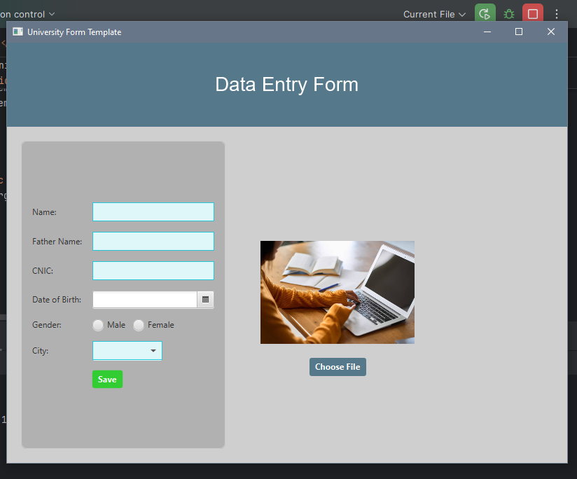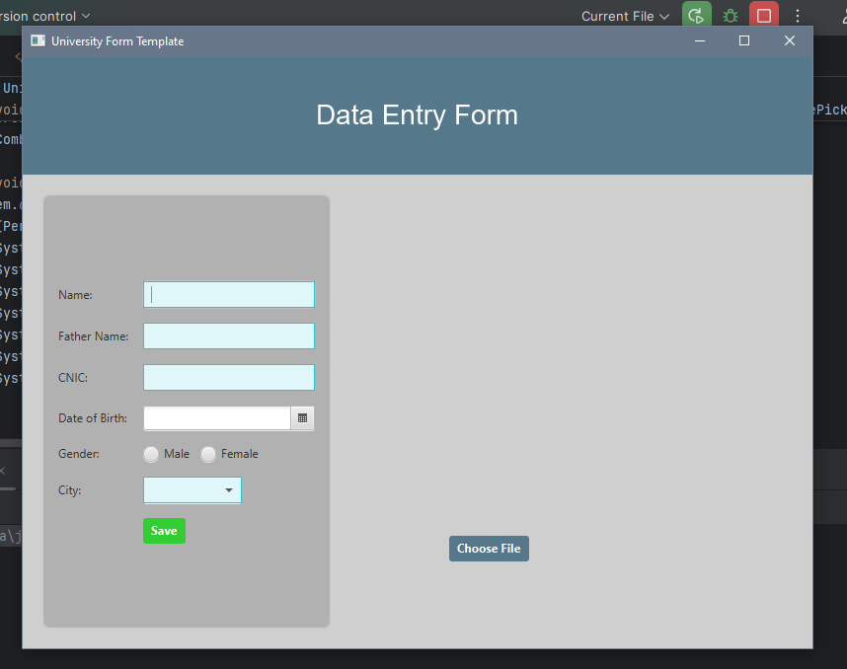

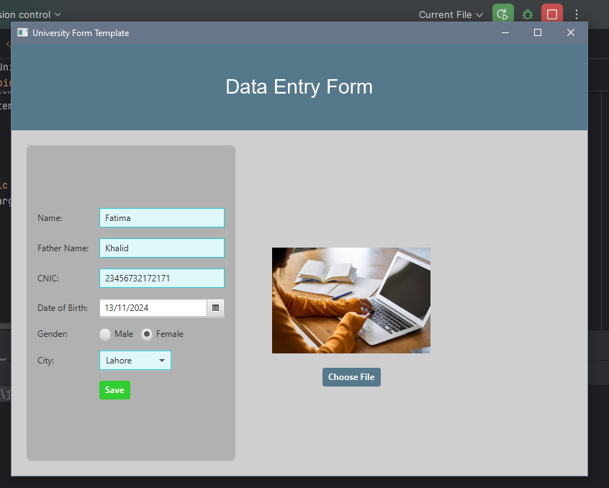

**Explanation of the code:**

#### ****How Code Works:****

* **Class Person:**
  + This is a blueprint for storing the information of a person.
  + It has fields like name, fatherName, cnic, dob, gender, and city to store user data.
  + It provides getters (methods to access the data).
* **Main Class UniversityFormApp:**
  + This is the main JavaFX application.
  + It sets up the layout and user interface of the form.
  + The data entered by users is saved into an ArrayList of Person objects.
  + After saving, the data is printed on the console.
* **Key Methods:**
  + **start Method:**
    - This method is where the entire form layout and design are created.
    - It includes:
      * **Banner:** Displays a title ("Data Entry Form") at the top with an image background.
      * **Form:** Contains input fields (e.g., Name, Father Name, etc.) and controls (e.g., a save button and file chooser).
      * **Image Section:** Lets users upload and display an image.
  + **savePersonData Method:**
    - Collects the data entered in the form fields.
    - Creates a Person object with this data.
    - Adds this object to an ArrayList and prints the list on the console.
  + **printPersonList Method:**
    - Prints the saved details of all persons in the console in a readable format.
* **File Chooser:**
  + Lets users pick an image file and displays it in the form.
* **UI Styling:**
  + The background colors, text styles, and alignment are set using CSS-like properties (setStyle method).

**JavaFX**

**Code for University Form:**

